These pompoms can make any occasion more festive, and it’s a great craft to do with kids or with a group of friends. It’s easy and, best of all, it’s cheap! You can get all the materials at the dollar store! You’ll need tissue paper (not crepe paper!), string or twine or yarn or floral wire, and scissors. That’s it!

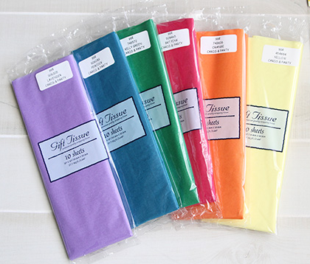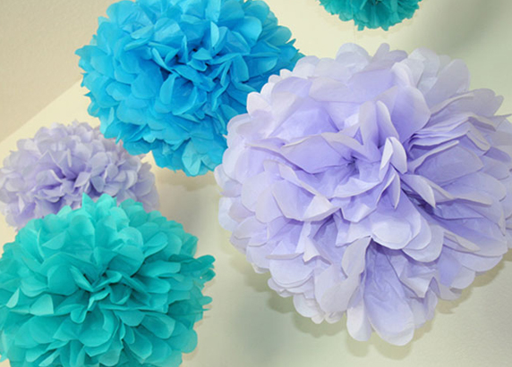

The instructions are below. There are also good videos on YouTube:

Large pompom balls: <https://www.youtube.com/watch?v=F2uVnIcAMm8>

Pompom garland: <https://www.youtube.com/watch?v=39-Tih6uYUc>

Small flower with stem: <https://www.youtube.com/watch?v=K59404x4D5w>

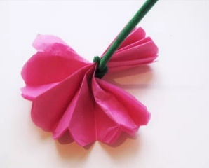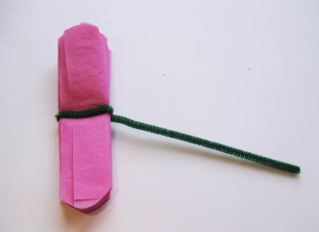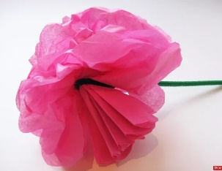

INSTRUCTIONS:

Take 8 to 20 sheets of tissue paper and lay them flat. The more paper, the larger and fluffier the pompom will be.

(For smaller pompoms, like for the flowers, just cut the tissue sheets.)

Fold accordion style (fold, flip over, fold, flip over, repeat) making 1” to 1 ½” folds. When you have the stack all folded up, give it a good crease.

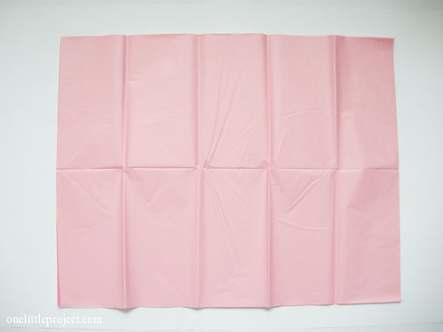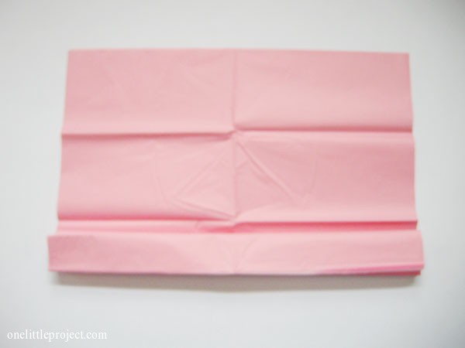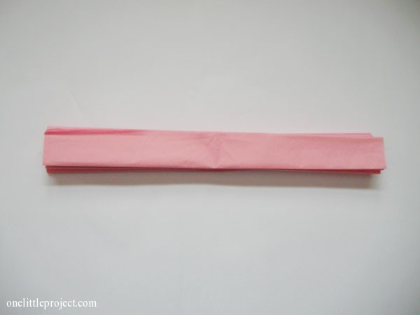

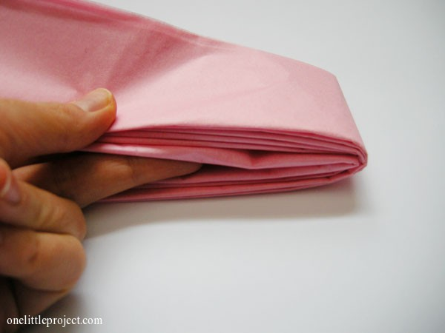Fold the stack in half at the center.

Wrap string or twine around the center of the stack and knot. Note: If you are going to make big pompoms to suspend from the ceiling, you can use a long length of string or filament and just keep one end long, or attach a long piece to the one you just tied.

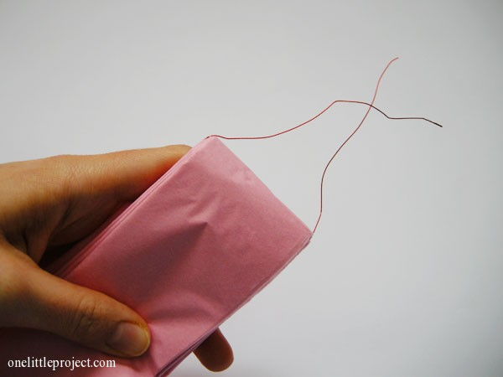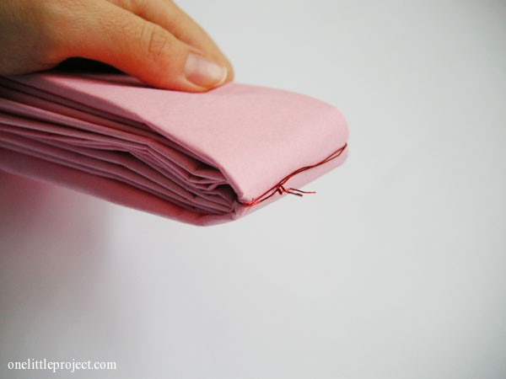

{If you are making small pompoms to make flowers (see <https://www.youtube.com/watch?v=K59404x4D5w>) use a stiff material like floral wire or a pipe cleaner to make a stem.}

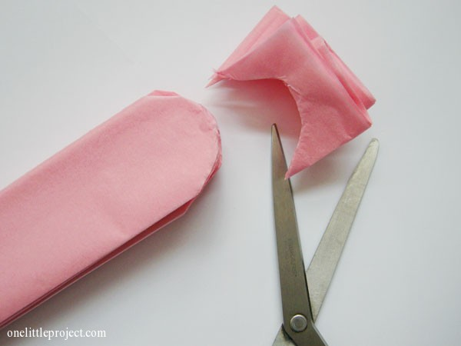Cut both ends. The shallower the cut, the shallower the “petals” of the tissue paper pompom will be.

You can cut the edges of the stack into different shapes, as shown below, to achieve different effects.

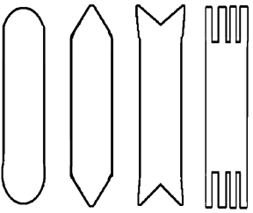

**Rounded**

**Pointed**

**Fishtail**

**Fringe**

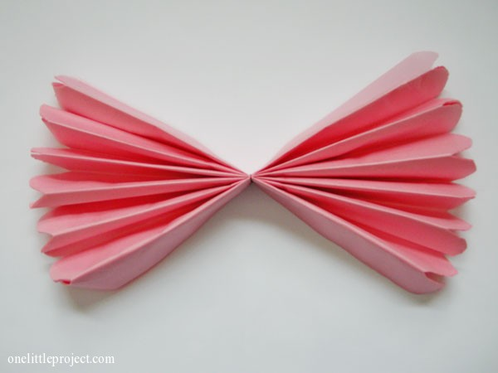Now you should have something that looks like this:

Now the part that requires a little patience. Take one piece of tissue paper and gently pull it up and away from the stack.

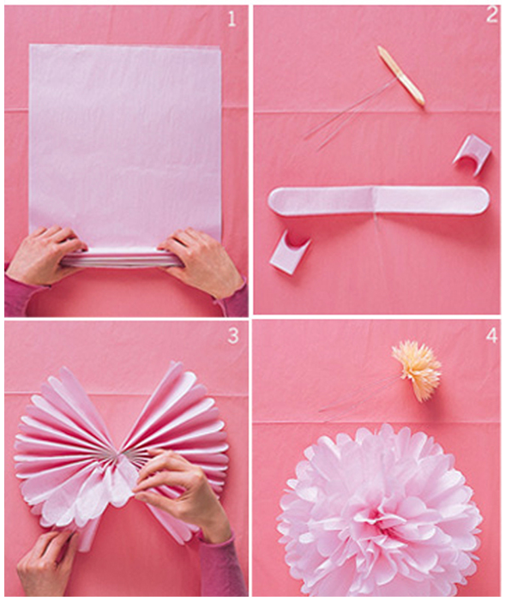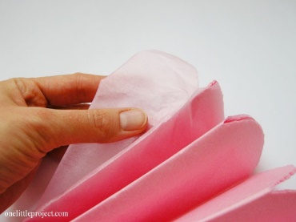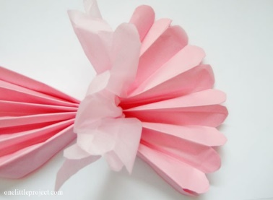

Continue pulling apart the layers of tissue paper on one side. Once you finish one half, pull apart the layers of the second half.

Fluff up all the layers until you get it into a good ball shape. Now it’s ready to hang or use as a table decoration.

