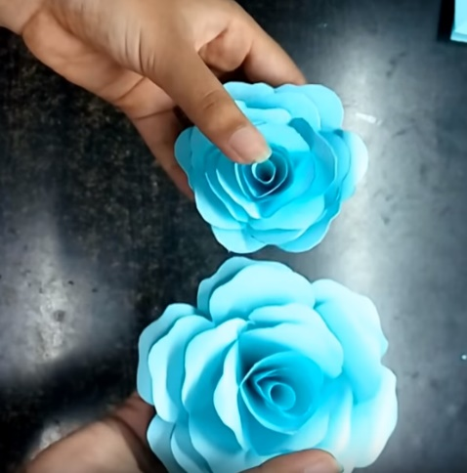**Easy Paper Roses**

A great craft to do with kids!

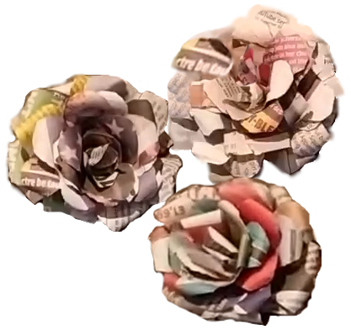Now you might be saying, “But I don’t have any craft paper or even colored computer paper.” Never fear. Everyone has junk mail. You can make these from newspaper, magazines, catalogs, or old books. Even ShopRite flyers. Pretty crafty, eh?

Here’s how:

<https://www.youtube.com/watch?v=SCdgIxWfvaQ&t=460s>

**OR**

<https://www.youtube.com/watch?v=mb19gQWPx_8>

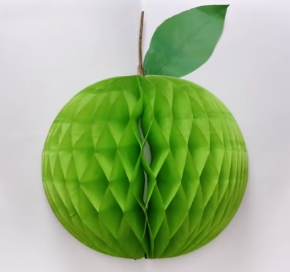**A Whole Bunch of Crafts**

Here’s a 15-minute video on “20 CHEAP BUT BRILLIANT EASY-TO-MAKE ITEMS.” Admittedly, some are not worth the time and effort, and some are *just plain silly*, but there are some real gems in there that are fun and easy to do!

<https://www.youtube.com/watch?v=jfhq195ZryU>

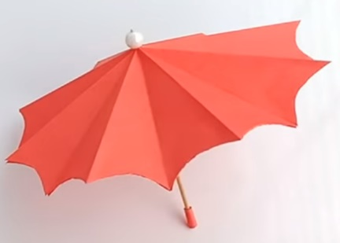

**Paper Parasol that Opens and Closes**

If you can do origami, you can do this.

<https://www.youtube.com/watch?v=WgPQHOPPkA4>

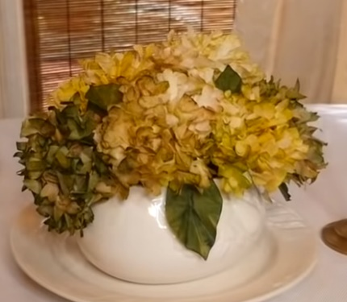

**Coffee Filter Hydrangeas**

A little time-consuming, but the results are awesome!

<https://www.youtube.com/watch?v=qOfLEhJsFpk>

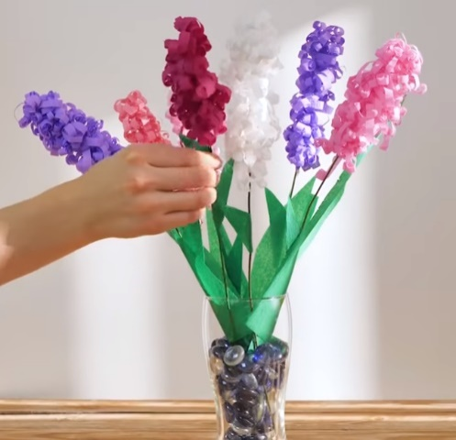**Easy Paper Decorations**

The decorations in the first 8 or so minutes of this video are easy and awesome! There are paper flowers, ornaments, garlands, and lots more, so knock yourself out!

<https://www.youtube.com/watch?v=Kr_pZ-ucpjk>

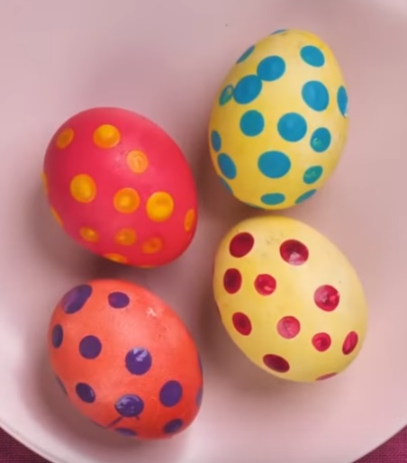

**Creative Easter Egg Coloring**

Check out these crazy and creative ways to color Easter eggs! **Note:** some of these are NOT edible.

<https://www.youtube.com/watch?v=bjpWM6ds6K0>

TIP: You can buy edible confetti, glitter, and other small decorations at Michaels or Walmart. Attach them to solid-colored eggs with royal icing.

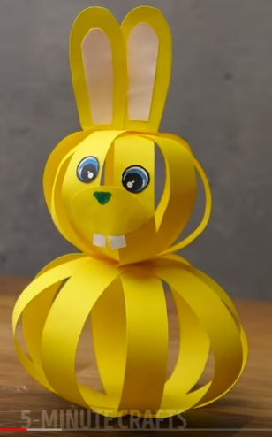

**Goofy Easter Bunny Decoration**

Another great, super-easy project to make with kids. You can also use this same technique to make a chick instead of a bunny by adding a paper beak and wings.

Go to <https://www.youtube.com/watch?v=RpiDQnu-n7g&t=901s> **to** **minute 6:16**.

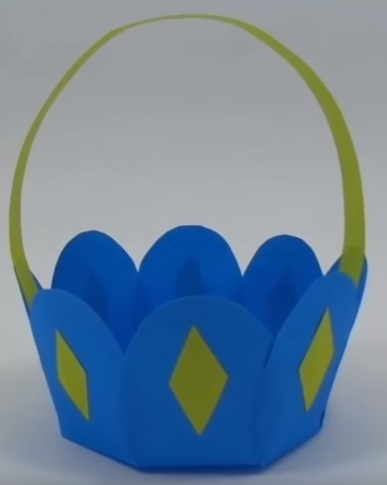

**Paper Flower Basket**

*Ridiculously easy!* Another kid-friendly craft and one that makes great party favors.

<https://www.youtube.com/watch?v=HSJPs9m91t0>