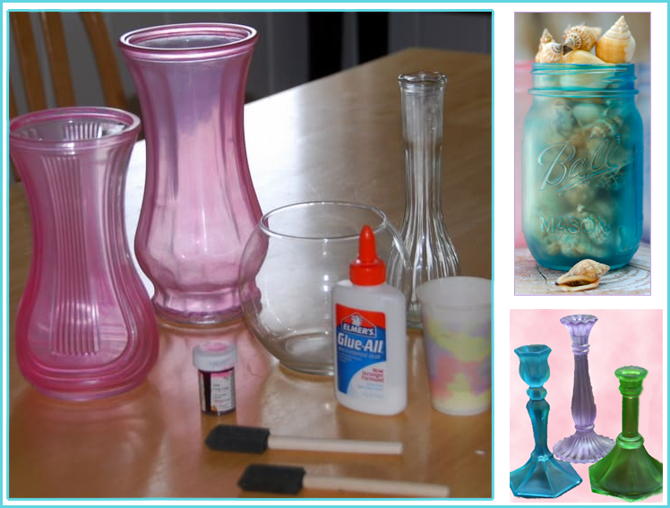**Elmer’s Glue Sea Glass**

Create a sea glass effect on clear glass. Mix 2 parts of glue with 1 part water. Add food color and mix. You can vary the intensity of color by the amount of food coloring you use. If you want a more transparent finish, you can add a little more water to the mixture. If you want a more opaque effect, apply multiple layers of the mixture onto the glass.

<https://www.youtube.com/watch?v=hV-iNM6WXQY>

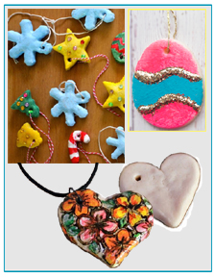

**Salt Dough**

Create ornaments, jewelry, gift tags, sculptures, refrigerator magnets, and anything else you can dream up.

Ingredients:

* 2 cups all-purpose flour
* 1 cup salt
* 1 cup cold water

1. In a large mixing bowl, stir together the [flour](https://amzn.to/2CsT0GF) and [salt](https://amzn.to/2CsUOzx).

2. Gradually add water while stirring and mixing to form a dough with a Play-Doh like consistency.

3. Form the dough into a ball and knead for approximately 5 minutes, adding a bit more flour if the dough is too sticky or a bit more water if it’s too dry. Let the dough rest for about 20 minutes.

4. Form the dough into shapes or use cookie cutters or cookie presses.

5. Put dough on a baking sheet and bake at 200 degrees. Baking time will vary depending on the size and thickness of your crafts, so just keep a close eye on them. The shapes should be hard and dry in about 2 hours. Allow to cool completely. Now you can decorate your shapes with craft paint or decoupage them. What?... no craft paint on hand? Use colored nail polish!